BIT3208: ADVANCED WEB DESIGN AND DEVELOPMENT
Student details
Student Name :Hibaq Abdi Muktar
Admission Number: BSCCS/2024/34174
Course:Computer Science
Unit Code: BIT3208
Unit Name: Advanced Web Design and Development
Lecturer Name: Mr. Michael Nyoro
Semester/Academic Year: 2025/2026
Project details
Project Title:SmartShop E-Commerce System
Selected Technologies: PHP + MySQL
GitHub link
https://github.com/Hibaq434/Smartshop-_Ecommerce.git

Contents
WEEK 1: LOCAL ENVIRONMENT SETUP 2
Title 2
Installation of XAMPP 2
Apache and MySQL Running 2
Localhost Test Page 3
Hello World Test 3
Database Connection Test 4
Student Reflection 4
Week 2: Wireframes and GUI Design 4
Dashboard Layout Design 5
Mobile View Mockup 6
Color Theme and Navigation Structure 7
GUI Prototype in Google Stitch 9
Week 3: JavaScript and PHP Basics 11
Password Strength Checker 12
Database Connection Script 13
Dynamic User Input Handling 13
Week 4: Server-Side Components and Backend Development Foundations 14
HTML Forms and PHP Integration 15
Simple Authentication System 16
Backend Folder Organization 19
Week 5: Database Components and CRUD Operations 20
Database Creation 20

WEEK 1: LOCAL ENVIRONMENT SETUP

Title

Installation of XAMPP
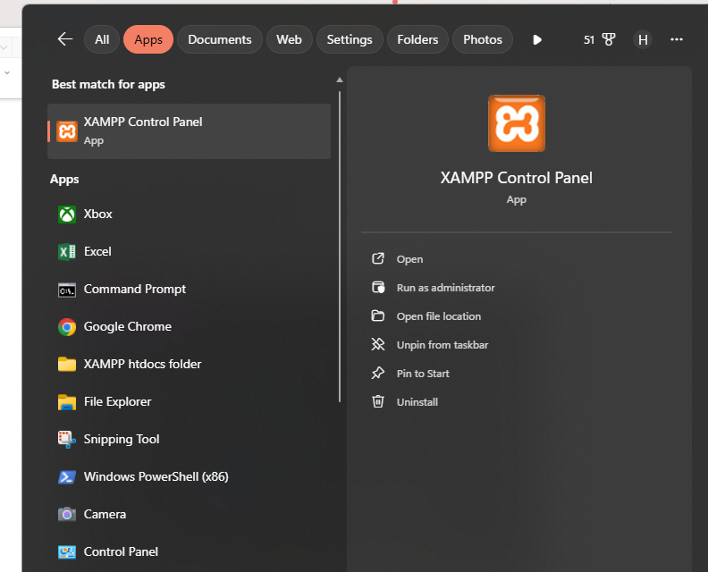
Fig 1 shows XAMPP Control Panel about dialog confirming XAMPP version 8.2.12 is installed and operational on the system.

Apache and MySQL Running
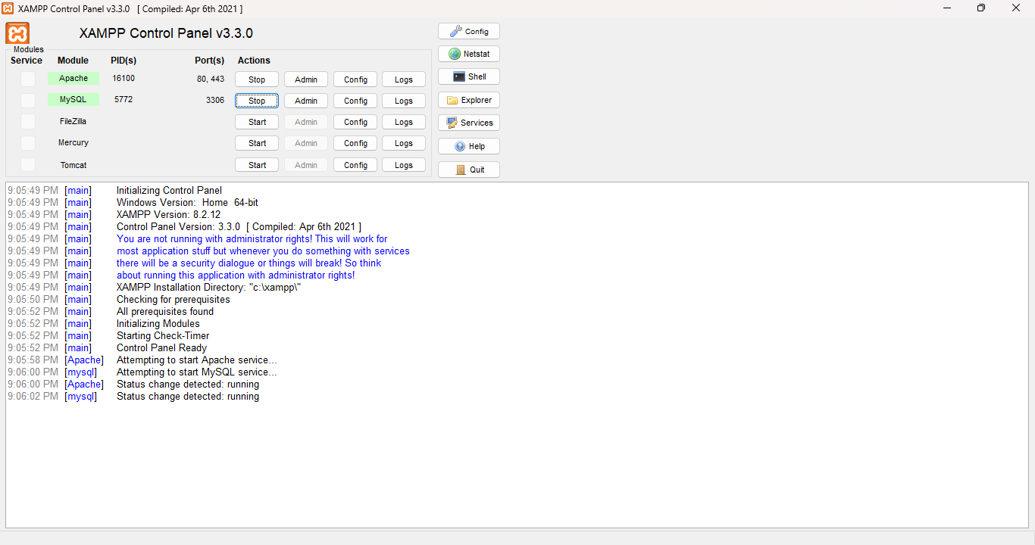
Fig 2 displays the XAMPP Control Panel with both Apache (Port 80) and MySQL (Port 3306) services running successfully, indicated by the green highlighting.

Localhost Test Page
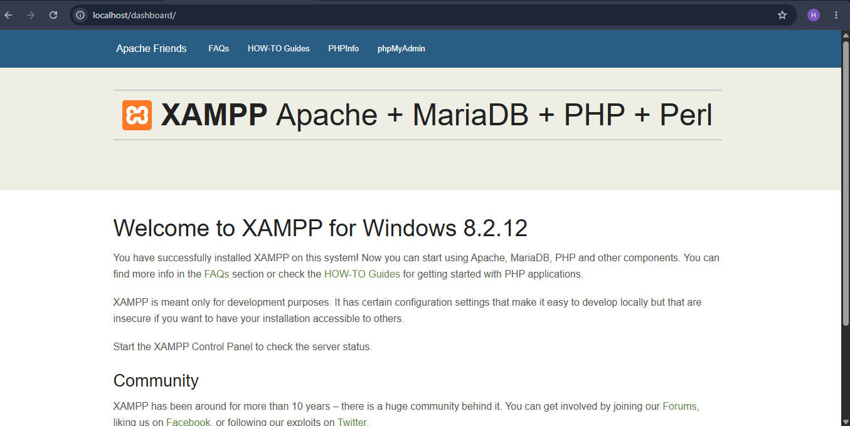
Fig 3 demonstrates localhost running successfully at http://localhost, displaying the directory listing of htdocs which confirms Apache is properly configured.

Hello World Test

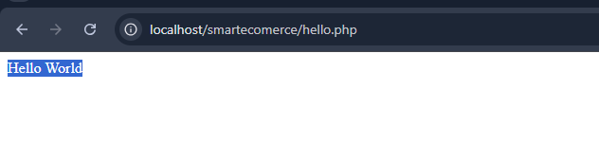
Fig 4 shows my Hello World test page at http://localhost/smartecomerce/hello.php which successfully executes both HTML and PHP code, confirming PHP integration with Apache.

Database Connection Test
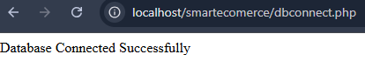
Fig 5 confirms successful MySQL database connection using mysql_connect(). The connection to smart_ecommerce_db on localhost using root user was verified, and ready status for database operations.

Student Reflection
During this week, I successfully configured the local development environment using XAMPP and verified that Apache and MySQL services were functioning correctly. I created and executed a Hello World PHP script through localhost to confirm PHP integration with the Apache server. Additionally, I established a successful connection between PHP and the MySQL database using mysqli_connect(). One challenge encountered was correctly configuring project directories and URLs inside the htdocs folder, which was resolved by using proper folder naming conventions. These activities improved my understanding of local server setup and backend connectivity in web development.

Week 2: Wireframes and GUI Design

Hand-drawn Wireframe
Login page
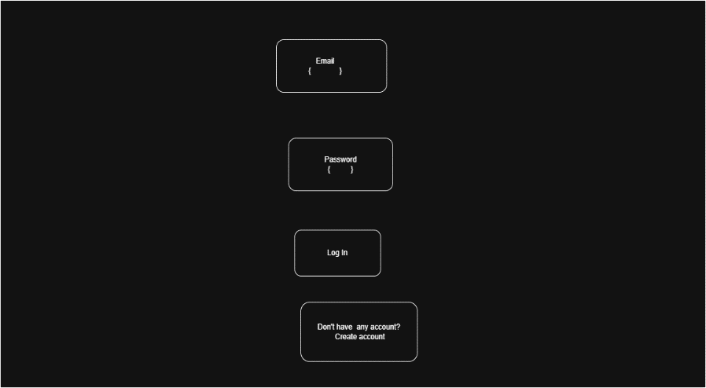

Fig 1 illustrates the SmartShop login page wireframe handrawn using drawer.io for the Smart E-Commerce System. The interface includes user authentication components such as email and password input fields, a login button and account registration option to support user access and navigation flow.

Dashboard Layout Design
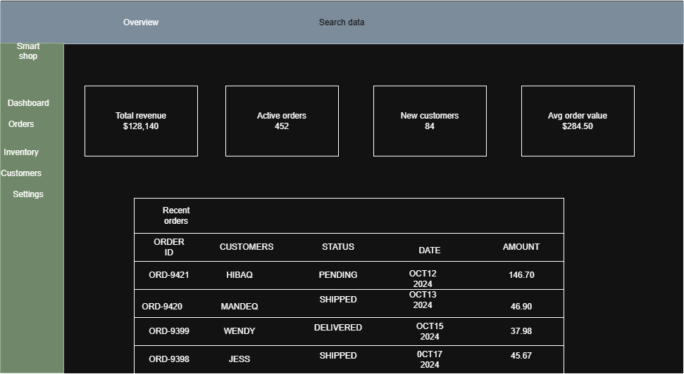

Fig 2 illustrates the SmartShop admin dashboard wireframe drawn using drawer.io. The interface includes revenue statistics, inventory monitoring, order management, navigation panels, and sales overview components designed to support administrative system operations.

Mobile View Mockup
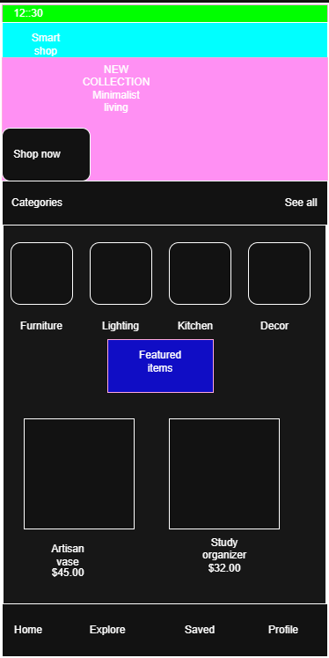
Fig 3 illustrates the SmartShop mobile view mockup drawn using drawer.io, demonstrating responsive interface design, mobile navigation structure, category organization, and product presentation for smartphone users.

Color Theme and Navigation Structure
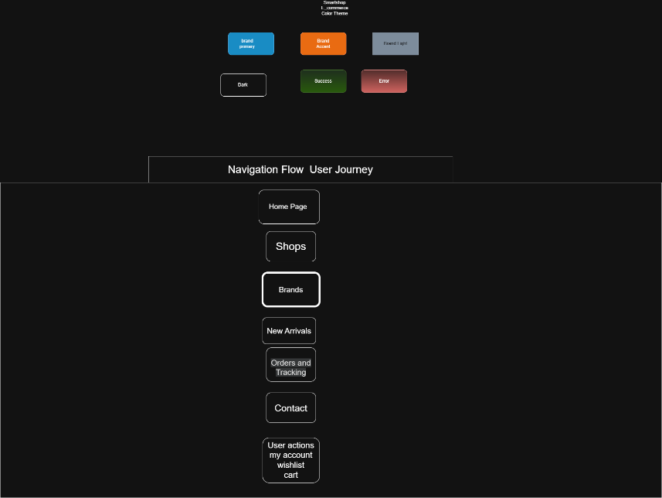
Figure 4 presents the color theme and navigation structure of the SmartShop E-Commerce System, providing an overview of how users interact with and navigate through the system.

GUI Prototype in drawer.io

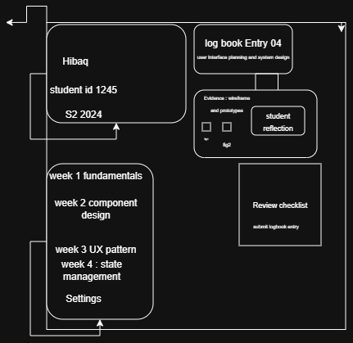

Fig 5 illustrates the SmartShop GUI prototype generated using drawer.io, showcasing the system layout, navigation structure, evidence management sections, and user interface organization for the academic logbook dashboard.

Week 3: JavaScript and PHP Basics
JavaScript Form Validation
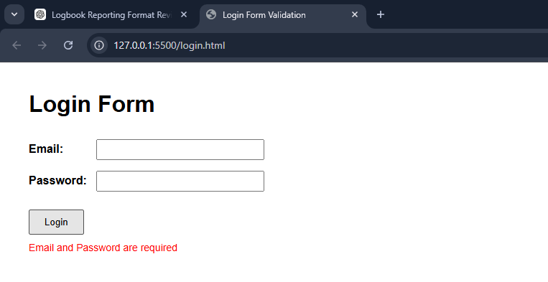
Fig 1 demonstrates JavaScript form validation implemented on the login page. The script checks for empty email and password fields, Red error messages are displayed when validation fails, while a green success message confirms successful validation when all inputs are correctly provided.

Password Strength Checker
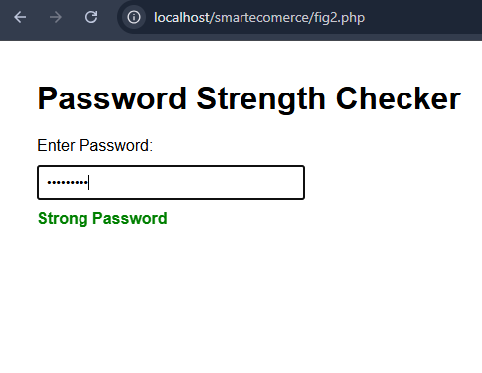
Fig 2 shows a JavaScript password strength checker that evaluates password length and displays weak, medium, or strong password indicators to improve user input validation.
PHP Syntax Practice
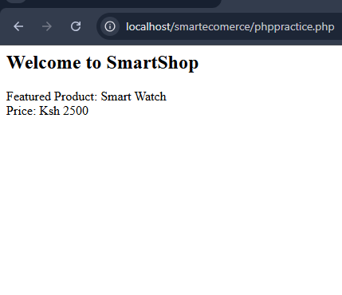
Fig 3 shows PHP syntax practice demonstrating variable declaration, string concatenation, and dynamic content output generation.

Database Connection Script
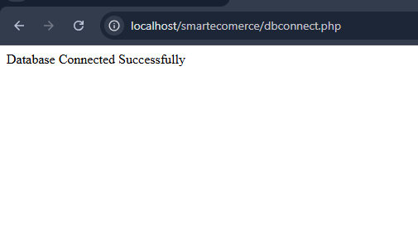
Fig 4 shows a successful database connection between PHP and MySQL using the mysqli_connect() function.

Dynamic User Input Handling
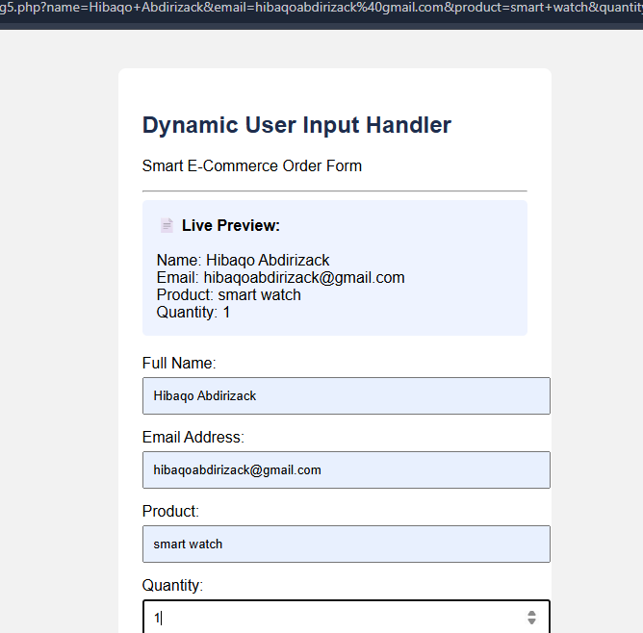
Fig 5 demonstrates dynamic user input handling using PHP and HTML forms to capture and display user-submitted data in real time.
Student Reflection
During this week, I implemented frontend and backend functionality using JavaScript and PHP. JavaScript was used to validate login form inputs and develop a password strength checker to improve user interaction and input validation. PHP scripting was also practiced through variable handling, dynamic content generation, database connection testing, and user input processing using forms. One challenge encountered was properly displaying validation messages and handling dynamic form data, which was resolved by improving the code structure and styling. These activities enhanced my understanding of how frontend and backend technologies interact in web application development.

Week 4: Server-Side Components and Backend Development Foundations
Understanding Server-Side Programming
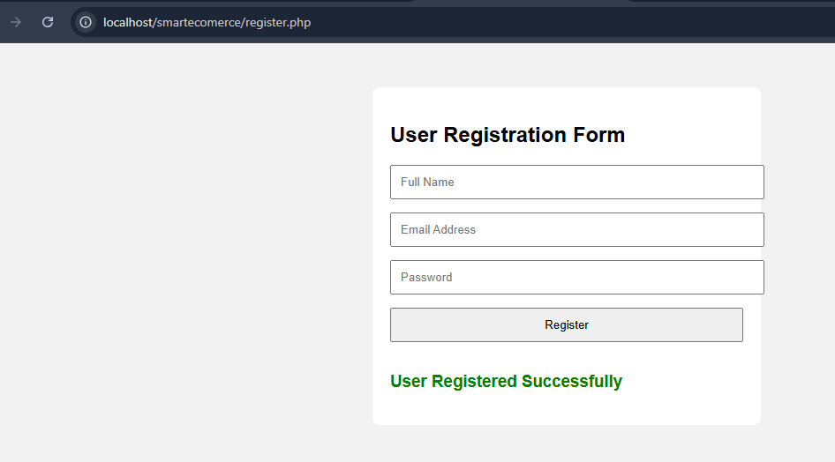

Fig 1 shows a user registration form developed using HTML and PHP to collect user information including full name, email address, and password for server-side processing.

HTML Forms and PHP Integration
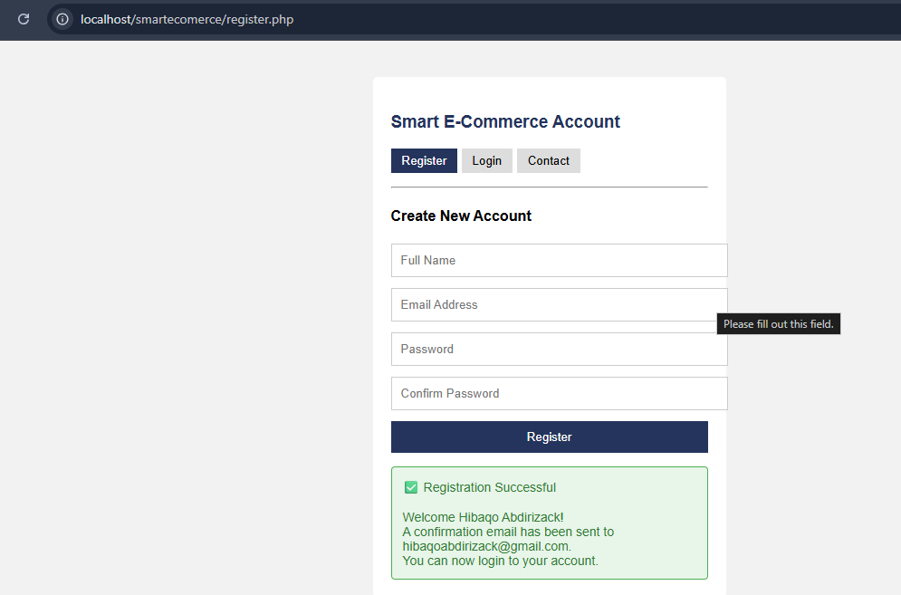

Fig 2a demonstrates HTML form submission and PHP integration used to process user registration details and display successful account creation feedback.
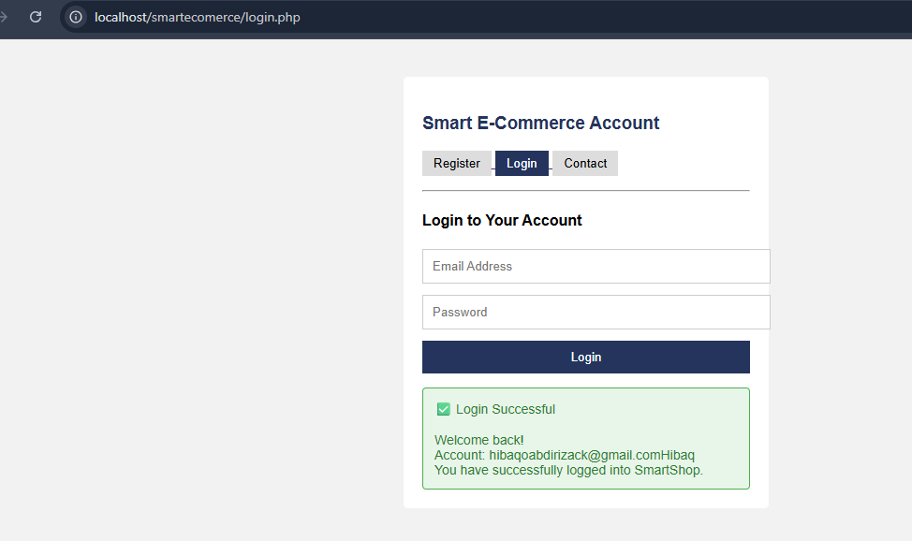
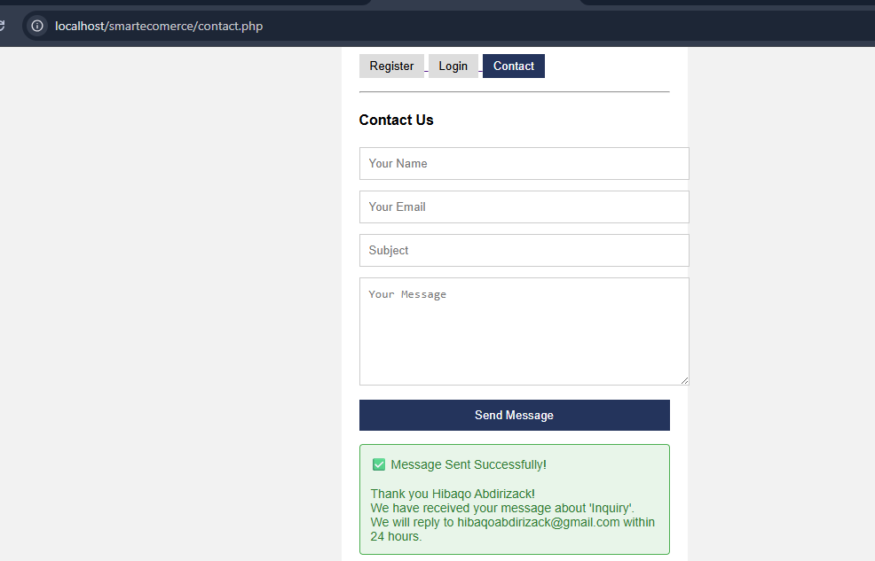

Simple Authentication System

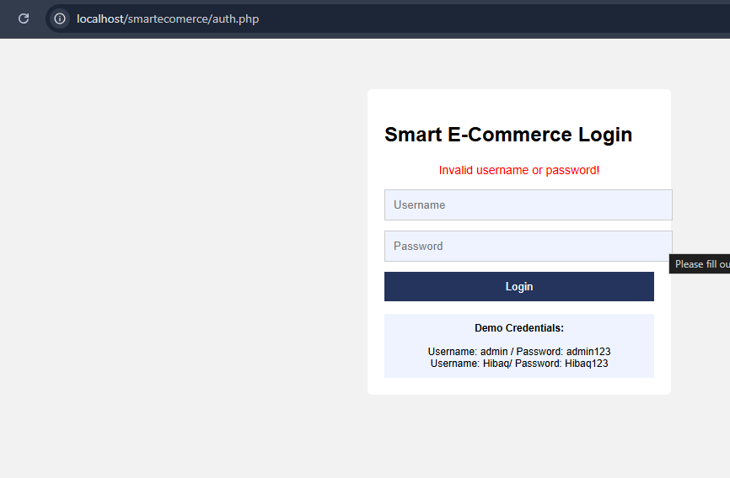
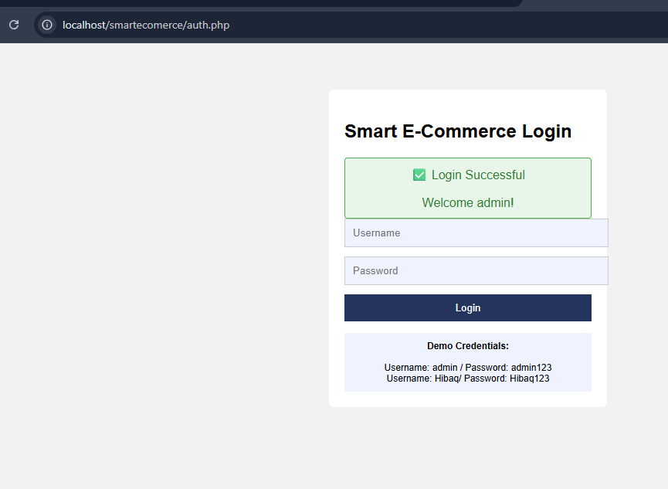

Backend Folder Organization
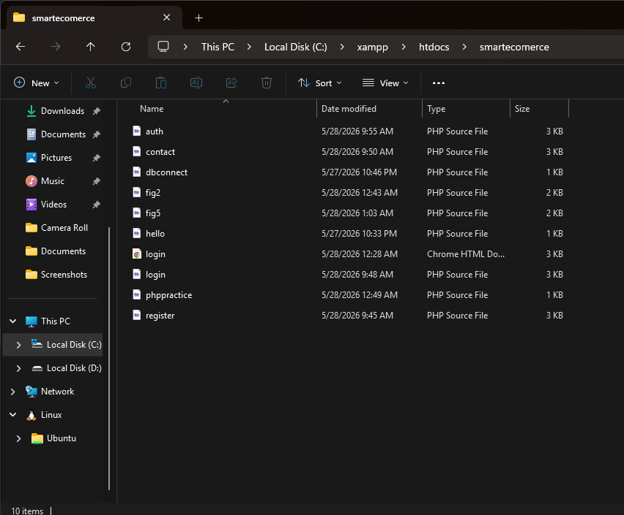
Fig 4 shows the backend folder organization of the SmartShop project, illustrating the structured arrangement of PHP files, assets, scripts, and project resources within the development environment.
Student reflection
During this week, I explored server-side programming concepts using PHP and MySQL in the SmartShop project. I developed user registration, login authentication, and contact form pages to handle user interaction and backend processing. PHP was used to process form data, validate login credentials, and generate dynamic success and error messages. I also organized backend files into structured folders to improve maintainability and workflow management. One challenge encountered was handling form submissions and page navigation correctly, which was resolved through debugging and improving file linking. These activities enhanced my understanding of backend development, authentication systems, and server-side data handling.

Week 5: Database Components and CRUD Operations

Database Creation
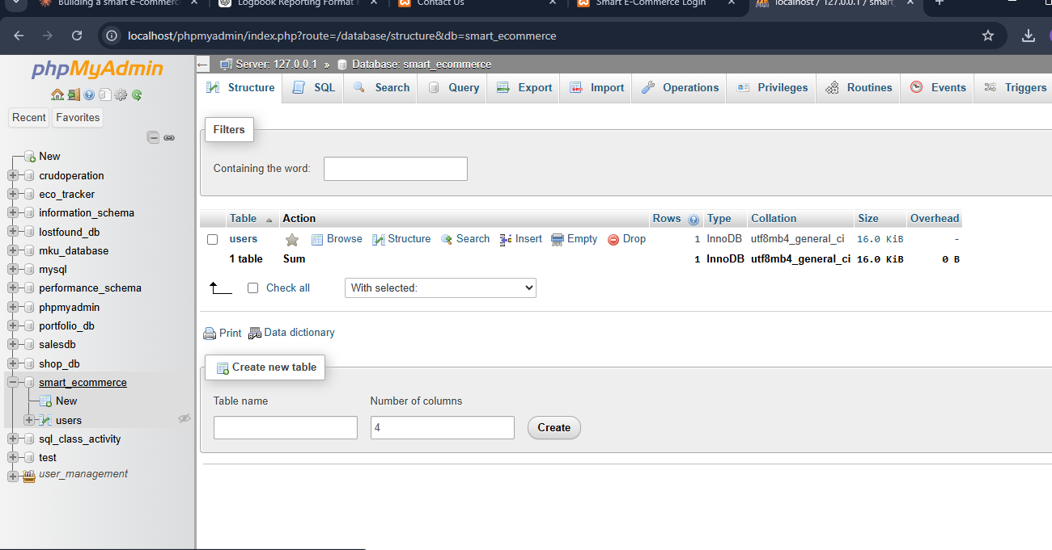
Fig 1 shows the creation of the smart_ecommerce database using phpMyAdmin within the XAMPP local development environment.
FIG 2 — Table Creation
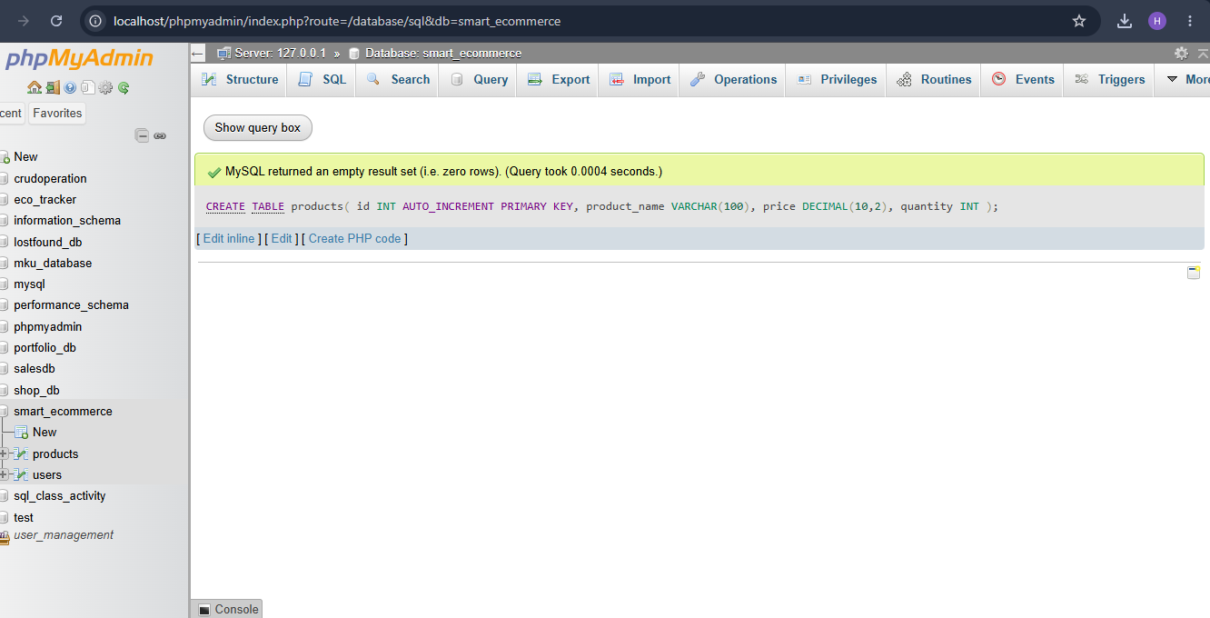
Fig 2 illustrates the creation of the products table containing product name, price, and quantity fields for managing SmartShop inventory records.
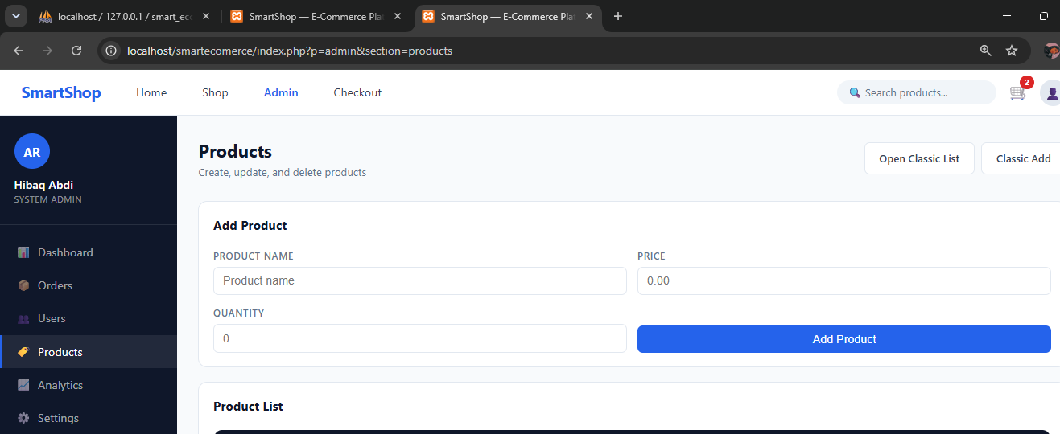
Fig 3 demonstrates the CREATE operation using PHP and MySQL to insert new product records into the database.
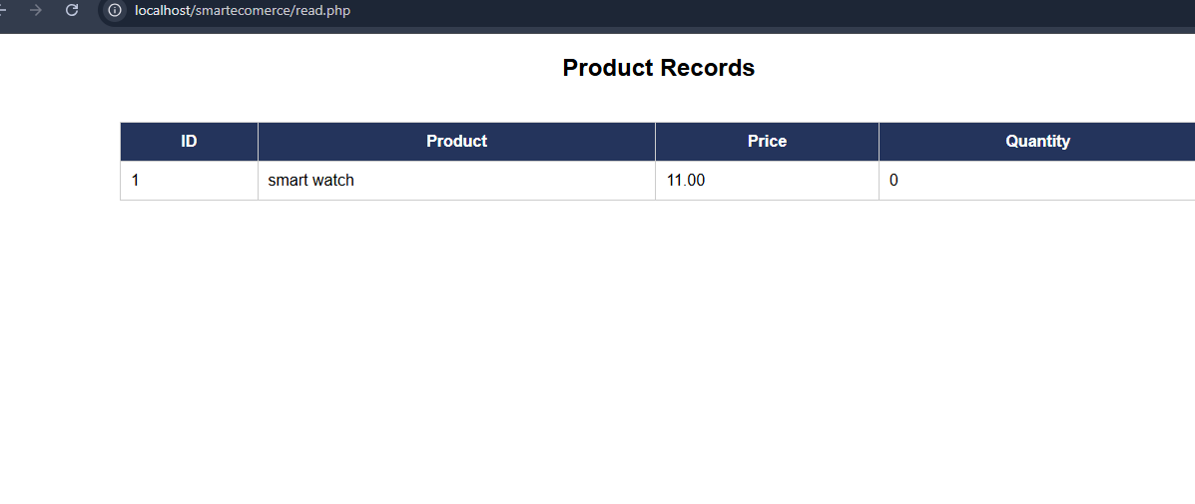
Fig 4 shows the READ operation used to retrieve and display product records from the MySQL database using PHP.
